Amwell Valley Hounds Blog
The Discerning Journal for those in the Know!
November 2016
Another Brilliant Amwell Valley Hounds Opening Day!
Written by Cheryl B
My dear husband is probably the only person in the world that thinks Opening Day is “all a bit of a fuss” and I believe this is because he still has the scars by having “that horse” who’d spend the entire time on his hind legs or dancing about. He never got the chance to enjoy the stirrup cup without throwing port over himself, or hear the blessing, or chat with friends.. . you get the picture. But on the other hand “I love Opening Day, the tradition; the pageantry, the attire, and I almost feel like I’m in the greatest show in town!” Said Cheryl B. This Sunday with 48 mounted riders, lots of friends and families, the dear Reverend Mark Spildoren who loves doing the blessing, plus the wedding, add to which there is the underlying fear of messing up over the first jump-provided an atmosphere of happiness, excitement and anticipation.
“We may not be the biggest hunt in the world but we do it well! Said Master Brian.
Getting married on horseback can be a little tricky- commented Master Cindy Nance, who tied the knot to John some seven years ago on horseback. But the day went perfectly, said Master Stephen who helped Franck lead the procession of Gentlemen into the Winery to wait for his intended. Christie wearing a stunning off white habit and hat with traditional veil and gloves and riding her steed Ditto ( a former grand prix jumper) side saddle, was flanked by Masters Joanne and Cindy resplendent in their scarlet coats.
The ladies of the hunt, wearing traditional black or navy blue shadbelly’s or formal attire and buttonaires joined the parade in pairs on their horses. Some wore top hats, yes not reserved only to the men and some bowlers, and each and every horse adorned braids and gleamed from grooming. They all managed to make it over the wooden bridge without incident.
The group of spectators cheered as Christie and Franck moved into position surrounded by the field.
The Reverend Spildoren in his baritone voice welcomed everyone and proceeded with the ceremony. Prayers were said, rings exchanged and a cheer went up when he announced “you may kiss the bride”. Pictured here is the happy couple doing just that, with the bride’s sister, Cheryl G looking on with a beaming smile, and Mum holding Ditto the horse.
While Christie was quickly getting changed and swapping hunt horses for the Opening Meet, the Reverend Mark Spildoren started the time old tradition of Blessing of the Hounds.
Amwell Opening Day (continued)
The field left the winery led by Master Joanne over the first double coup without incident, and pictures were captured by Paws and Rewind. The second flight followed smoothly led by Master Cindy. Holly who was leading the Third Flight noted later in the day. “There were a few issues” when four horses took a dislike to the first ditch. August Torsileri, horse trainer jumped off to lead his horse over, and Andy Dobbs (name of horse) decided it would be easier to jump, and leapt over him. “I just looked up to see his belly!” He said. One way to get everyone on their way, and a quick check of a saddle that had moved, meant Third flight had a bit of catching up to do!
Meanwhile the Hunt continued moving across to Mr. McConaughy’s land and then onto Dr. Glogau’s before jumping a coup left into Weilenta’s Farm. “This is such a great view” said Dan Wasserstrom, riding up front on his dependable horse Lady. We stopped on Runyon Mill Road to gather hounds and the entire Hunt met up. Dr. Wendy Furlong seemed worried about her husband Dr. Brendan Furlong and former Master who seemed to have disappeared. We later learned he had a case of” Man Flu”- and had to call it a day.
It is always wonderful to see our trusty Road Whips, Laurie and Bruce, directing traffic and today we also had several car followers, including MP- who was unable to ride due to broken bones in her foot and Lauren Podraza, who we very much miss out Hunting.
Mr. Farrin led hounds up Mr. and Mrs. Ward’s drive onto Riding Mill Farm. “This is always a favorite place of mine due to all the jumps” said Ruth, whose plucky little horse never falters over a jump. Doing a circuit of the jumps twice, the field once more stopped to let hounds catch their breath and we were off over a large roll top back across Ward’s land and over a coup onto Russo’s. We then crossed Wertsville Rd, which thankfully had little traffic and along the edge of The Ridge Golf Club, crossed Back Brook into Big Sky Farm.
There had been much galloping until we saw two panicked trail riders and so walked calmly on so as not to agitate their horses and once clear galloped on up over the hills onto Mrs. Schwab’s via tractor hill and two more coops.
By this time we had been out almost 3 hours, hip flasks had run dry, biscuits eaten (said Donna and Lisa) when we crossed Back Brook further up and put Charlie Fox to ground in the stunning beach woods.
So now more than 3 ½ hours out, the Masters decided it was time to head home…….
All the while Claire Taylor had been snapping away, gathering the best photos no doubt for Amwell Valley Hounds Calendar (remember to place your order in early due to demand). We also met up with Jen Stevens and her team who captured tired but happy Fox Hunters heading home.

Christie and Franck Tie the Knot in Style!
At Unionville Winery
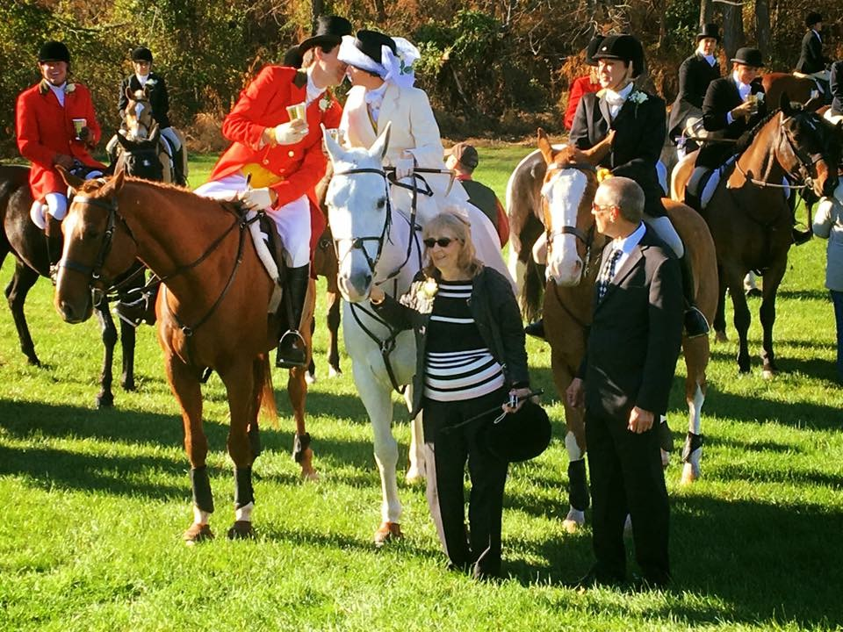
Photography curtesy of Claire Taylor
“The weather couldn’t have been better” said the Reverend Spildoren who officiated at the Wedding of Christie and Frank. He also said that he had married many couples in his life but never any on horseback!
These Fox Hunters met through their passion for riding and the countryside when Franck was introduced to Christie at such a Meet. Was it love at first sight? “I’m not sure” says Barbara Peterson who introduced the happy couple, “but there were certainly sparks flying over the breakfast”. Their friendship clearly blossomed and Franck a scientist at a local pharmaceutical company popped the question. Because they met out Hunting, Christie asked the Masters of AVH if they could celebrate their wedding “in the field”, and where better than the biggest day on the Hunting calendar The Opening Meet.
No Tin Cans Needed Here!

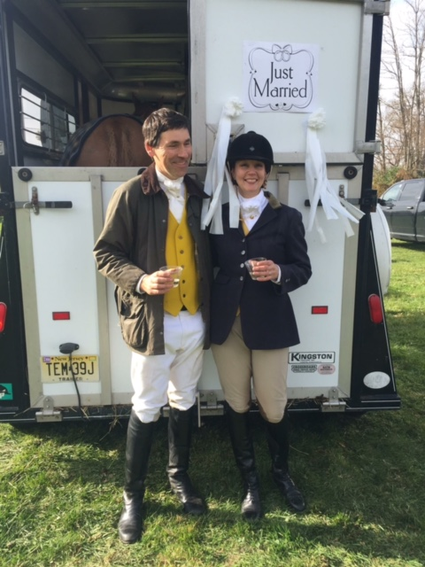
Decorations completed by Mr. & Mrs. Peter Shebey.
Every bride dreams about leaving her wedding in style, be it a gleaming white limousine or a horse drawn carriage. But as you have probably gathered Christie and Franck have developed their own style of wedding and pictured here is the happy couple, standing next to their decorated Horse Trailer. Wearing hunt attire Christie and Franck had just completed a wedding and full Opening Meet hunt in 4 hours. “It was a wonderful surprise to return to the car park and see this” said Christie. Little did they know that while out hunting, Cheryl Buxton had arranged for mutual friends of the couple to decorate their trailer. However, there was some angst that as the trailer had been moved perhaps they had decorated the wrong one! Panicked calls were made to friends and family, who all couldn’t remember what color truck Franck had. But all was well in the end and of course no tin cans could be tied on in case this upset the Great Mr. Nichols, the horse Christie had borrowed to go out hunting on. His butt can just be seen in the picture!
Byline - Use this style for the name of the author of an article.
Byline Company - Use this style to type the author’s

Who introduced Christie and Franck??
Our very own Barb Peterson- little did she know it would lead to The I do’s!

continued on page 2

Inside This Issue
1 | Amwell Valley Hounds Opening Day
2 | The Wedding of the Year
3 | Behind the Scenes
4 | No cans needed here!
5  6 | Photographs are up  Fun Facts
Continued on page 2
continued from page 1

PHOTOGRAPHS ARE UP!

I’m sure we can all recall photographs of disastrous wedding scenes, where the entire entourage falls into the water when the dock they are standing on collapses, or the bride slips on the floor and reveals way too much of her underwear, (or lack of it!!).

Christie and Franck’s Wedding had all the ingredients of being magnificent or well… you know amusing in years to come but agony at the time. Just think about it, the actual wedding on horseback, the Minister standing next to them on the ground along with the Best Lady, 48 pals on horses, 54 hounds, spectators, excitement.

But with three official photographers from Paws and Rewind, and Priscilla and the many spectators so many things could have gone awry. But there are some beautiful colorful scenes. Jen Stevenson the Owner of Paws and Rewind stayed up to 2am on Sunday and you can view the hundreds of photos and buy your prints by going to:
https://pawsandrewind.smugmug.com/Equestrian-Events-2016/November-6-2016

Polite reminder, please do not copy photos off the site to post on Facebook without buying a print or gaining permission from Jen, you will be in breach of Copyright!
……………………………….
The Recipe for Success!!
- Great Weather-check
- Great setting-check
- Great props- (horses, hounds, costumes)-check
- Create an atmosphere of excitement and happiness- check
- Organization-check
- Photography to remember the events-check
- Food-in the evening- check
- Participants-check
- Great Hunting-check
- Stars of the Show-check

continued from page 1

Opening Day Tea Held at Timberlake Farm…

The Opening Meet Tea was a cracking success, and held at Christie and Franck’s Timberland Farm. The bride and groom provided masses of main courses at and as always Hunt Members and Supporters were asked to contribute to the Tea. The result was quite a feast. Franck’s best Man’s speech was delightful and Franck was reminded that he had said, all he wanted was to find someone who would love him and love horses as much as he did- Ahhs were heard, then Cheryl G welcomed Franck into their family and the rather imposing six layered cake was cut! While all of this was going on we could hear dear old Heathrop a retired hound, wanting to get in on the action. It was also lovely to see Carol-Ann and Bob return from Florida and good to see their former home once again filled with such happiness.

Behind the Scenes
“There is an incredible amount to do prior to Our Opening Meet” …
Honorable Secretary, Sue DeHaven noted, having sent out invitations to Hunt Members and Supporters some weeks earlier. While the Happy Couple were making wedding arrangements, Masters Stephen and Mr. Farrin were visiting landowners to ensure we were given the green light to ride over their land. Then jumps were checked and paths cleared, and one coup moved on the winery. Just to ensure there would be good sport on the day, hunt fixtures were moved to West Amwell.

There was also a good deal of debate behind the scenes, who should or would lead in the parade, where would everyone stand, when would hounds come in, whether Scram our Huntsman’s horse could stand still that long, how many hounds should come out, how many flowers to buy .. Discussions had with Unionville Winery who once again was gracious to allow us to use their field for our venue and were excited about hosting a wedding.

A small team, Masters Cindy and Joanne, Sue, Maria, Angie and I nipped over to decorate the Winery as a surprise for the event. Joanne even brought a bag of flour to mark out two hearts where the Bride and Groom should position themselves! Port was bought, silver cups polished, button holes made.

You can replace the pictures in this template with your
Choose a new picture, and click the Link to File box if you don’t want to save the art with the newsletter.
change line properties and crop the image. For more detailed editing, double-click on the graphic to activate the drawing layer.

Facts and Figures
Q: How many Opening Day Meets has Amwell Valley Hounds has over the years?
A:
Q: What has been the largest field out riding on the day?
A: This year we had 48 riders in 3 flights, plus 4 Masters, Our Huntsman and 3 Hunt Staff.
Q: How many bottles of Port were consumed for the Stirrup Cup?
A: 6 bottles, which we of course purchase from our host Unionville Winery
Q” How Many hounds did Mr. Farrin bring out for the Opening Meet?
A: 16 couple of Hounds
Q: How many jumps did the first flight fly over?
A: 25, Master Joanne did one more as she jumped the coup onto Wertsville Rd
Q: Who might be a contender for the Slippery Saddle Award?
A: Gabriella dismounted twice, (but elegantly!) Our Hon Sec had a bit of a spill when her new enthusiastic horse took off after jumping a coup and went down a gully. Scratched nose (Sue not the horse) but both fine!
Q: How long did the Reverend Spildoren take to marry Christine and Franck?
A: 14.5 min. until “You may kiss the bride” was said!
Q: I hear being in third flight was a bit eventful?
A: Yes. Firstly 4 horses refused to do through the first ditch, Gus dismounted to lead his horse (Andy Dobbs) who decided to jump over him! One saddle came askew.
Q: How many former Masters attended Opening Day?
A: Ralph, Ron, Brendan, and Hon Master Tiffany.
Q: what was the temperature on Sunday?
A: a high of 62 degrees.
Q: why was the blog written this way?
A: Because the author got stumped as to how to write an article that didn’t sound sappy!

